Project Title
SALES ANALYSIS PROJECT REPORT (POWER BI)
1. Objective
The objective of this project is to build an interactive Power BI dashboard to analyze sales performance based on different dimensions like category, region, customer segment, and payment mode.
This helps businesses make data-driven decisions and track growth.

2. Dataset Description
The dataset contains transactional sales data with the following attributes:
- Row ID
- Order ID
- Order Date
- Ship Date
- Ship Mode
- Customer ID
- Customer Name
- Segment
- Country, City, State, Region
- Product ID
- Category
- Sub-Category
- Product Name
- Sales
- Quantity
- Profit
- Returns
- Payment Mode
- ind1, ind2

3. Data Cleaning & Transformation
Performed in Power BI (Power Query Editor):
- Removed duplicate records
- Handled missing/null values
- Converted date columns into proper format
- Created relationships (if multiple tables)
- Ensured correct data types
- Created measures:
  - Total Sales = SUM(Sales)
  - Total Profit = SUM(Profit)
  - Total Quantity = SUM(Quantity)

4. Dashboard Design
- Added Title using:
Home → Insert → Text Box → “SALES DASHBOARD”
- Clean layout with proper alignment
- Soft color theme for readability
- Added Region slicer (Tile format) for filtering

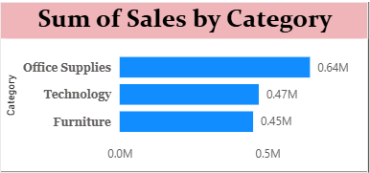
5. Visualizations Used
📌 1. Sum of Sales by Category
- Chart: Clustered Bar Chart
- Insight: Office Supplies leads in total sales

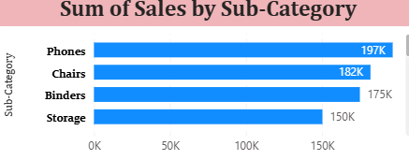
📌 2. Sum of Sales by Sub-Category
- Chart: Clustered Bar Charts
- Insight: Phones and Chairs generate highest revenue
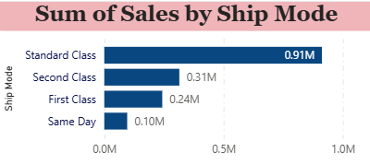
📌 3. Sum of Sales by Ship Mode
- Chart: Clustered Bar Chart
- Insight: Standard Class is the most used shipping method

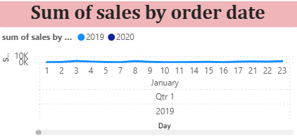
📌 4. Sum of Sales by Order Date
- Chart: Stacked Area Chart
- Insight: Sales show gradual increase over time

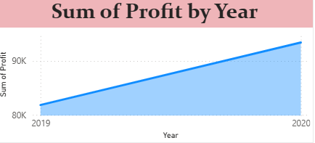
📌 5. Sum of Profit by Order Date
- Chart: Stacked Area Chart
- Insight: Profit is increasing year by year

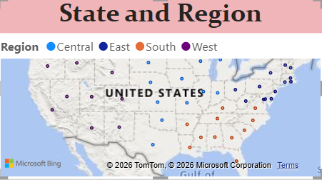
📌 6. State and Region Map
- Chart: Map Visualization
- Settings Applied:
  - File → Options → Map & Filled Map enabled
  - Bubble Size → Sum of Sales
  - Tooltip → Sum of Profit
- Insight: Regional performance varies across states

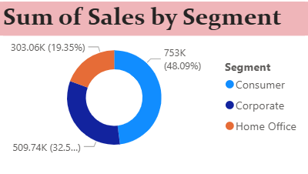
📌 7. Sum of Sales by Segment
- Chart: Donut Chart
- Segments: Consumer, Corporate, Home Office
- Insight: Consumer segment contributes highest sales

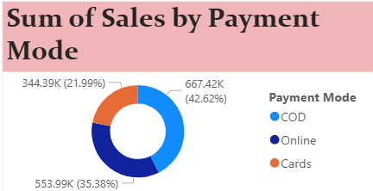
📌 8. Sum of Sales by Payment Mode
- Chart: Donut Chart
- Modes: COD, Online, Cards
- Insight: COD is most preferred payment method

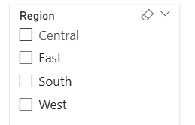
📌 9. Region Slicer
- Type: Tile Slicer
- Regions: Central, East, South, West
- Purpose: Allows dynamic filtering of dashboard

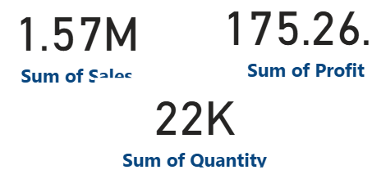
📌 10. KPI Cards
- Total Sales: 1.57M
- Total Profit: 175.26K
- Total Quantity: 22K

6. Key Insights
- 📈 Sales are growing steadily over time
- 🏆 Office Supplies is top-performing category
- 📱 Phones are best-selling sub-category
- 🚚 Standard shipping dominates
- 👥 Consumer segment drives most revenue
- 💳 COD is the most used payment method
- 🌍 Regional analysis shows uneven sales distribution

7. Conclusion
The Power BI dashboard provides a clear and interactive view of sales performance.
It helps in:
- Identifying top products and categories
- Understanding customer behavior
- Monitoring profit trends
- Making strategic business decisions

8. Future Scope
- Add forecasting (AI visuals)
- Include customer retention analysis
- Create drill-through reports
- Connect with real-time data sources

9. Final Output
✔ Interactive Power BI Dashboard
✔ Business Insights Visualization
✔ Easy-to-understand reports for decision-making
